**Forum:** Disarmament Council

**Issue:** Facilitating peace talks in the Israel-Palestine conflict

**Student Officer:** Joshua Pan

**Position:** Chair of Disarmament Commission

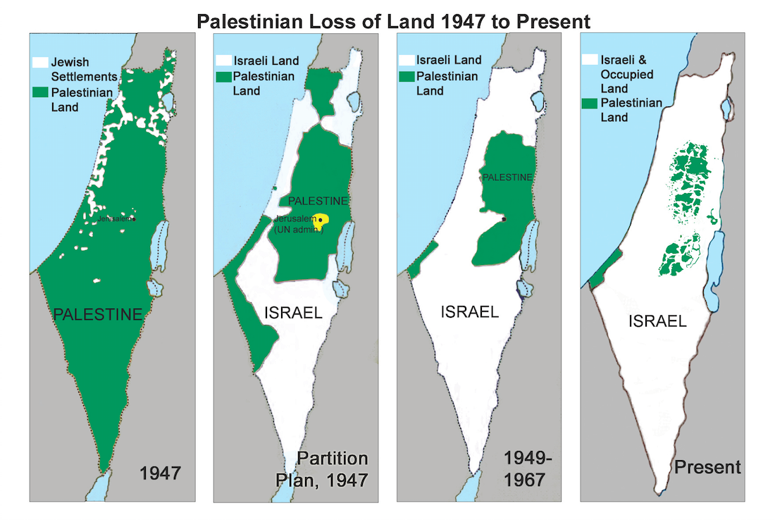Introduction

The Israeli-Palestinian conflict started with the unilateral declaration of the Zionist state of Israel in 1948. Following that, there was widespread unrest amongst the native Arab Palestinian population. After Israel’s consolidation of power in the first Arab-Israeli war, the Israeli government expelled more than 650,000 native Palestinians.

Palestinian land lost from 1947 to the present day

After two Arab-Israeli wars, several conflicts between Israel, Palestinian forces and the surrounding Arab nations, there were already efforts trying to establish peace. Israel signed peace treaties with Egypt and Jordan, which both countries engaged in conflict with the Israeli forces. The establishment of the state of Palestine in 1988 also pushed the two states to seek means of peace.

In 1993, the Israeli prime minister Yitzhak Rabin and the president of the state of Palestine met in Oslo, accompanied with then American president Bill Clinton to discuss means of peace. A peace plan was drafted, which supported a two-state solution. Another peace summit was hosted in Camp David, USA in 2000, where the political leaders of both states met, yet no solution was met.

Since then, there have been several peace talks and attempts of dialogue, but with the growing hostilities between the two sides, especially with Israel’s aggressive actions of building illegal settlements in the West Bank and East Jerusalem, as well as actions of using violence to stop demonstrations, the peace process has been hindered.

Definition of Key Terms

Region of Palestine

A historical region in the Levant of the Middle East, comprised of the modern states of Palestine (East Jerusalem, West Bank, Gaza Strip) and Israel.

State of Palestine

A sovereign state that holds observer status in the United Nations. Founded in 1988 and is an important entity to ensure the two-state solution between Palestine and Israel. Currently comprised of the Gaza Strip, West Bank and East Jerusalem (large areas in the latter two regions currently under illegal Israeli occupation)

Zionism and the state of Israel

Zionism is the political idea of the Jewish people possessing its own state in the region of Palestine, with Jerusalem being its capital. The ideals of this ideology pushed the establishment and declaration of the State of Israel in 1948.

UN partition plan, 1947

An UN proposal to split the region of Palestine into a Jewish and an Arab state and was mostly rejected by the Arab communities and many Jewish peoples. Ultimately, the plan gave supposed legitimacy to the formation of Israel.

Jerusalem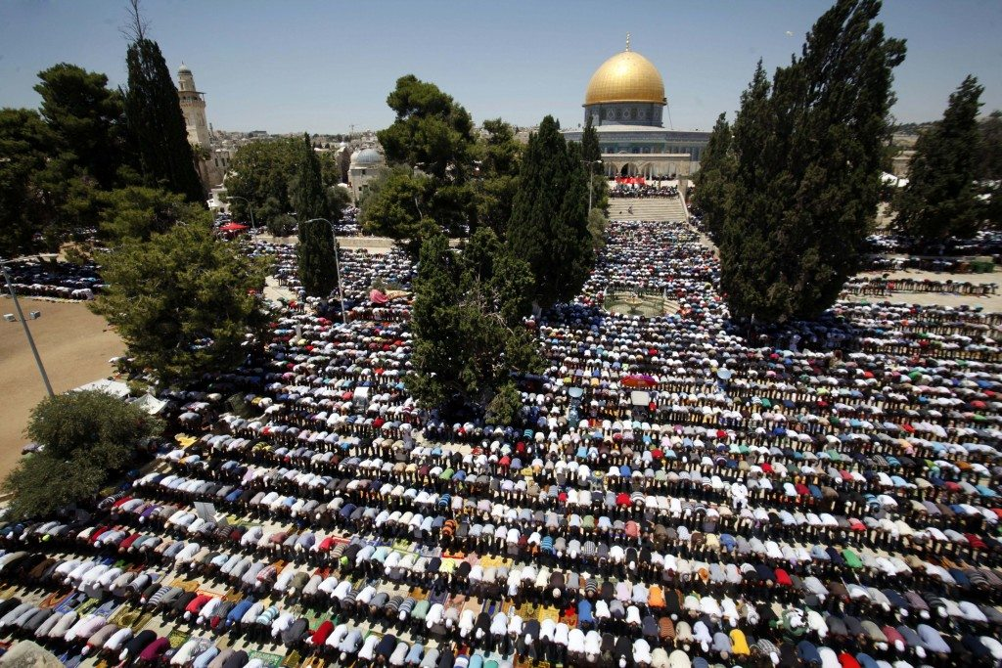

The holy city of the three Abrahamic religions: Islam, Judaism and Christianity. The status of the city has been one of the center points of the Israeli-Palestinian conflict, as both states seemed jurisdiction over the city to proclaim its legitimacy to exist.

Muslims praying in Masjid Al-Aqsa, Jerusalem

One-state solution

A proposal for peace that would unite the region of Palestine into a single, secular and democratic state, much like the nation of Lebanon. It was a possibility during the proposal of the partition plan, yet it was rejected. In recent times, this solution been frequently brought up to bring the conflict into solution.

Two-state solution

Separation of the Jewish state and an Arab state, in the form of Israel and Palestine.

Three-state solution

Proposal of having a Jewish and Arab state, with the city of Jerusalem being an international zone which falls under the jurisdiction of neither countries.

Israeli occupation of East Jerusalem and the West Bank

After the Arab-Israeli war of 1967, Israel was militarily occupying the Palestinian areas of East Jerusalem and the West Bank. The UN deemed the occupation illegal, and Israel received widespread condemnation internationally for infringing upon the territorial sovereignty of the Palestinian state.

Oslo Accords, 1993

It was an agreement signed by the leaders of Israel and the state of Palestine, yet it left important issues like the status of Israeli settlements in the occupied territories without agreement.

Hamas and Fatah

The two political factions within the Palestinian state. Hamas is an Islamist political faction that calls for a more militaristic approach in the liberation of the Palestinian state. It is currently now in full control over the Gaza Strip, and has conducted rocket attacks on Israel. It is deemed as a ‘terrorist organization’ by Israel and several other states like the United States. Fatah is a more moderate and secular party led by Mahmoud Abbas, the president of the state of Palestine.

Israeli settlements in the occupied territories

There are currently 121 Israeli-recognized settlements in the occupied territories of the West Bank and East Jerusalem. The government of Israel encourages Jewish settlers to settle in Palestinian areas under Israeli occupation, and to replace the preexisting Palestinian communities in those areas. 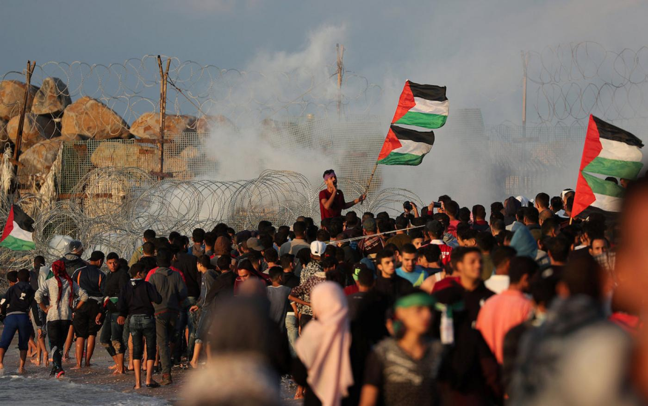In 2004, the International Court of Justice deemed the settlements to be a clear breach of international law, and it acted as a human rights violation.

Gaza Protests, 2014-now

As Gaza is administered by Hamas, which is recognized as a terrorist group by Israel, Israel constructed a border wall around the Gaza Strip and put the region on blockade since 2014. It sparked widespread protests amongst the Palestinians in Gaza, where Hamas also sponsored rocket attacks to Israel. The Israeli Defense Force (IDF) shot and killed 183 protesters and injured more than 8,000 to a degree of seriousness.

Protest events in the Gaza Strip, Palestine

US moving it’s embassy to Israel to Jerusalem

The US government formally recognized Jerusalem as the ‘undivided capital of Israel’ in 2017, under President Donald Trump. Later that year, the US announced its move to relocate the US embassy to Israel from Tel-Aviv to Jerusalem and received widespread international criticism for this move. The UN General Assembly voted a resolution to condemn this decision, with the wide majority of countries voting in favor.

General Overview

The Israeli-Palestinian conflict is currently ongoing, with Israel conducting a complete blockade on the Gaza Strip, as well as militarily occupying the Palestinian Territories of east Jerusalem and the West Bank. Following the establishment and unilateral declaration of the Jewish state in Palestine in 1948, fighting broke out between Israel and the neighboring Arab states: Egypt, Lebanon, Syria and Jordan. As the first Arab-Israeli war was brought to a conclusion, Israel cemented its control over their claimed territories, as well as acquiring new lands and expelling Arab inhabitants. Officially, the West Bank and East Jerusalem were annexed by the kingdom of Jordan, and the Gaza Strip under Egyptian administration.

A second Arab-Israeli war broke out in 1967, with Israel preemptively striking Egyptian air fields, disabling almost the entire Egyptian Air Force. The war ended with Israeli victory, and the occupation of the Palestinian Territories plus the Sinai peninsula of Egypt. Importantly, the borders of the Arab and Jewish state before the 1967 war is commonly referred to as the 1967 borders.

Israel also began to sign peace treaties to its formerly hostile neighbors of Egypt and Jordan. Around the same time, a settlement policy was implemented by the Israeli administration, which effectively moved Jewish settlers into the occupied Palestinian Territories. By the end of 1977, 31 settlements taken root in the West Bank, with 4,500 state sponsored Jewish settlers. In 1980, a UNSC passed, which deemed the pacifying efforts of Israel and its military occupation illegal, yet further actions were not taken. A centralized Palestinian authority was able to be established, and the state of Palestine was established in 1988. At approximately the same time, Israel increased its settlements by 60%, with 120 settlements being built at the end of the decade with 100,500 settlers.

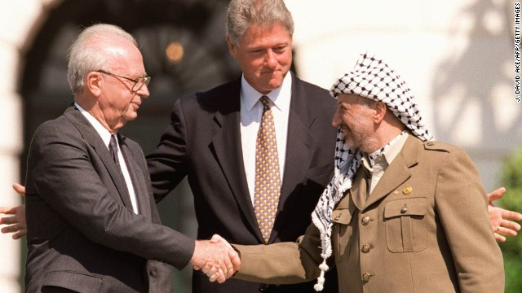

The first efforts of peace took place in 1993, with the signing of the Oslo Accords between the administration of both countries. Agreements were reached in terms of maintaining peace, yet important issues like the question of settlements, as well as the status of Jerusalem were left untouched. As a follow up, in 1995, the Oslo II Accords were signed, which allowed democratic elections in the Palestinian areas.

Israeli PM Yitzhak Rabin and leader of the PLO Yasser Arafat shaking hands during the Oslo Accords

The peace efforts deteriorated as violence began to increase. In 2000, when the Israeli opposition leader, Ariel Sharon, made a provocative visit to Masjid Al-Aqsa, the third holiest site in Islam, located in East Jerusalem. Palestinians protested and soon, the situation escalated to widespread violence, which ended the Oslo peace treaties. Israel since then has tightened its grip on the occupied territories, and even went as far as building a border wall between Israel and the Gaza Strip, which Hamas has control over. In 2017, The US moved its embassy in Israel from Tel-Aviv to Jerusalem, which initiated a new round of widespread unrest in Palestine. Protests and conflicts are still occurring and the chances of peace are quite slim.

UN Involvement, Relevant Resolutions, Treaties and Events

The UN has facilitated the process of establishing a two-state solution in Palestine by proposing UN General Assembly Resolution 181 in 1947, yet the unilateral Declaration of Independence has brought complications, as Israel declared its independence without UN agreement. Israel was admitted into the UN in 1949, despite popular disagreement in the international community.

The UNSC Resolution 446 in 1979 called for an immediate stop to all actions, altering the 1967 borders and establishing the nature of Israeli settlements as illegal. Unsurprisingly, Israel has neglected the demands of the resolution.

Resolution 1397 in 2002 called for the cessation of all forms of violence in Palestine and set the vision for a two-state solution, yet the resolution was largely useless. A resolution was proposed by the US to reaffirm the status of Jerusalem and referred the city as ‘the eternal and undivided capital of Israel.’ The Resolution was a failure as most countries voted against it.

Timeline of Events

|  |  |
| --- | --- |
| **Date** | **Description of event** |
| 1947 | UN Partition Plan of 1947 - possible solution to the division of Palestine after British rule |
| May 14th, 1948 | Unilateral Declaration of Independence - marks the establishment of the Jewish state and hostility of its Arab neighbors |
| 1948-49 | First Arab-Israeli War - Israel’s consolidation to its administration |
| 1967 | Second Arab-Israeli War, agreement of the 1967 borders - Redefined the Israeli-Arab borders, massive territorial gains made by Israel |
| 1979 | Security council resolution 446 - deemed Israeli occupation of the Palestinian territories to be illegal |
| 1988 | State of Palestine formed |
| 1991 | Oslo Accords - a major attempt towards peaceful solutions |
| 2017 | American embassy to Israel moved to Jerusalem |

Possible Solutions

One of the peace proposals is to unite the region of Palestine into a single, secular and democratic state, much like the nation of Lebanon. It is a way to end the dispute of the Holy Land by proposing a united government without a clear religious dominance. It was a possibility during the proposal of the partition plan, yet it was rejected. In recent times, this solution been frequently brought up to bring the conflict into solution.

The most popular solution is to entertain the two-state solution with a Jewish and Arab state, and Jerusalem split between west and east. It was brought up several times through UN resolutions, and peace talks were made to attempt to achieve this goal. Yet, the possibility of peacefully resolving the conflict and achieving the two-state solution is quite slim, as tensions between the states continues to rise.

There are also proposals of setting Jerusalem as an international zone, to maintain equilibrium and sort out the question regarding the status of Jerusalem, since the holy city is one of the focuses of the fighting between both sides.

Bibliography

“Blockade.” The Free Dictionary, Farlex, www.thefreedictionary.com/blockade.

“Israel Profile - Timeline.” BBC News, BBC, 9 Apr. 2019, www.bbc.com/news/world-middle-east- 29123668.

“Israel's Wars & Operations.” First Intifada, www.jewishvirtuallibrary.org/first-intifada. Kostiw, Nick, et al. “Home.” Ethical Culture Society of Bergen County NJ, 11 Apr. 2012,

“Oslo Accords.” History.com, A&E Television Networks, 16 Feb. 2018, www.history.com/topics/middle-east/oslo-accords.

The Guardian, Guardian News and Media, 14 May 2018, www.theguardian.com/commentisfree/2018/may/14/the-guardian-view-on-gaza-shootings- stop-killing-unarmed-civilians.

“The Guardian View on Gaza Shootings: Stop Killing Unarmed Civilians | Editorial.”